MODUL-4

1) What are the main factors that can affect PPC bidding?

Ans.

**1. Quality Score**

* **Definition**: A metric used by platforms like Google Ads that evaluates the quality and relevance of your ads, keywords, and landing pages.
* **Impact**: Higher Quality Scores can lower your cost per click (CPC) and improve ad positioning.

**2. Keyword Competition**

* **Definition**: How many advertisers are bidding on the same keyword.
* **Impact**: High competition increases CPC because more advertisers are vying for the same audience.

**3. Bid Amount**

* **Definition**: The maximum amount you're willing to pay per click.
* **Impact**: Directly influences your ad’s placement in the auction process.

**4. Ad Relevance**

* **Definition**: How closely your ad matches the user’s intent and search query.
* **Impact**: More relevant ads often get better placements and lower costs.

**5. Landing Page Experience**

* **Definition**: The relevance, speed, and usability of the page users land on after clicking your ad.
* **Impact**: A better experience can increase conversion rates and improve your Quality Score.

**6. Click-Through Rate (CTR)**

* **Definition**: The percentage of people who click your ad after seeing it.
* **Impact**: Higher CTR often improves Quality Score and lowers CPC.

**7. Ad Extensions**

* **Definition**: Additional pieces of information (like phone numbers or links) that can be added to your ad.
* **Impact**: They improve ad visibility and CTR, indirectly influencing bidding efficiency.

**8. Device Targeting**

* **Definition**: Choosing to show ads on mobile, desktop, or tablet.
* **Impact**: Performance and cost can vary based on device type.

**9. Geographic Location**

* **Definition**: Targeting specific regions or countries.
* **Impact**: Bidding costs and competition levels often vary by location.

**10. Time of Day & Day of Week**

* **Definition**: Scheduling ads to run during specific hours or days.
* **Impact**: Performance and costs can fluctuate based on user behavior patterns.

**11. Industry Trends & Seasonality**

* **Definition**: Market trends and seasonal events affecting user behavior.
* **Impact**: Certain times of year (e.g., holidays) often see increased competition and CPCs.

**12. Budget Constraints**

* **Definition**: The total amount you're willing to spend daily or monthly.
* **Impact**: A limited budget can restrict your ad visibility and competitiveness.

2) How does a search engine calculate actual CPC?

Ans.

A **search engine** (like Google Ads) calculates the **actual cost-per-click (CPC)** based on a real-time auction process, not just your maximum bid. Here's how it works:

**Formula for Actual CPC**

Actual CPC=Ad Rank of the advertiser below youYour Quality Score+$0.01\text{Actual CPC} = \frac{\text{Ad Rank of the advertiser below you}}{\text{Your Quality Score}} + \$0.01Actual CPC=Your Quality ScoreAd Rank of the advertiser below you​+$0.01

**Key Terms Explained**

* **Ad Rank**: A value used to determine your ad position. It’s calculated as:

Ad Rank=Max CPC Bid×Quality Score\text{Ad Rank} = \text{Max CPC Bid} \times \text{Quality Score}Ad Rank=Max CPC Bid×Quality Score

* **Quality Score**: Google assigns a score (1–10) based on:
  + Expected click-through rate (CTR)
  + Ad relevance
  + Landing page experience
* **Ad Rank of the advertiser below you**: The competitor whose ad ranks immediately below yours in the auction.

**What This Means Practically**

* You **don’t pay your full max bid**you only pay **just enough to beat the next competitor**.
* If your **Quality Score is high**, your **actual CPC can be much lower** than your max bid.
* If your **Quality Score is low**, you may **pay more** to maintain the same position.

**Example**

| **Advertiser** | **Max CPC** | **Quality Score** | **Ad Rank (Bid × QS)** |
| --- | --- | --- | --- |
| A (You) | $4.00 | 8 | 32 |
| B | $5.00 | 5 | 25 |

**Your Actual CPC = (Ad Rank of B / Your Quality Score) + $0.01**

=258+0.01=3.13+0.01=$3.14= \frac{25}{8} + 0.01 = 3.13 + 0.01 = \$3.14=825​+0.01=3.13+0.01=$3.14

Even though your bid was $4.00, **you only pay $3.14**.

3) What is a quality score and why it is important for Ads?

Ans.

### **What Is a Quality Score?**

**Quality Score** is a metric used by search engines (like Google Ads) to measure the **relevance and quality** of your ads, keywords, and landing pages.

It’s scored on a **scale of 1 to 10**, with **10 being the highest**. A higher score means your ad and landing page are more relevant to the user’s search intent.

### **Components of Quality Score**

1. **Expected Click-Through Rate (CTR)**
   * How likely your ad is to be clicked when shown.
   * Based on historical data and ad performance.
2. **Ad Relevance**
   * How closely your ad matches the user's search intent and keywords.
3. **Landing Page Experience**
   * How useful, relevant, and user-friendly the landing page is after someone clicks your ad.

### **Why Is Quality Score Important?**

#### **1.** Lower Cost-Per-Click (CPC)

* Higher Quality Score = **Lower actual CPC**
* You pay less for each click compared to advertisers with lower scores.

#### **2.** Better Ad Position

* Your **Ad Rank** (which determines placement) = **Max Bid × Quality Score**
* So, a high Quality Score helps you win better positions **even with lower bids**.

#### **3.** Higher Return on Investment (ROI)

* Relevant ads lead to more clicks and conversions.
* You spend less for better performance.

#### **4.** Improved User Experience

* Google rewards advertisers who provide relevant and useful experiences to users.
* This encourages more trustworthy and effective advertising.

### **Example**

| **Advertiser** | **Max CPC** | **Quality Score** | **Ad Rank** |
| --- | --- | --- | --- |
| You | $2.00 | 9 | 18 |
| Competitor | $3.00 | 5 | 15 |

Despite bidding less, **you win a better ad position** because your **Quality Score is higher**.

4) Create an ad for your website/ blog in Google Ads that display on the display network with the properly targeted audience.

Ans.

Step:1

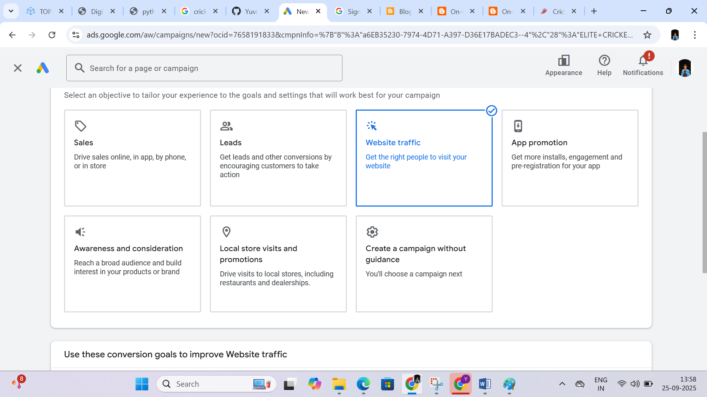

Step:2

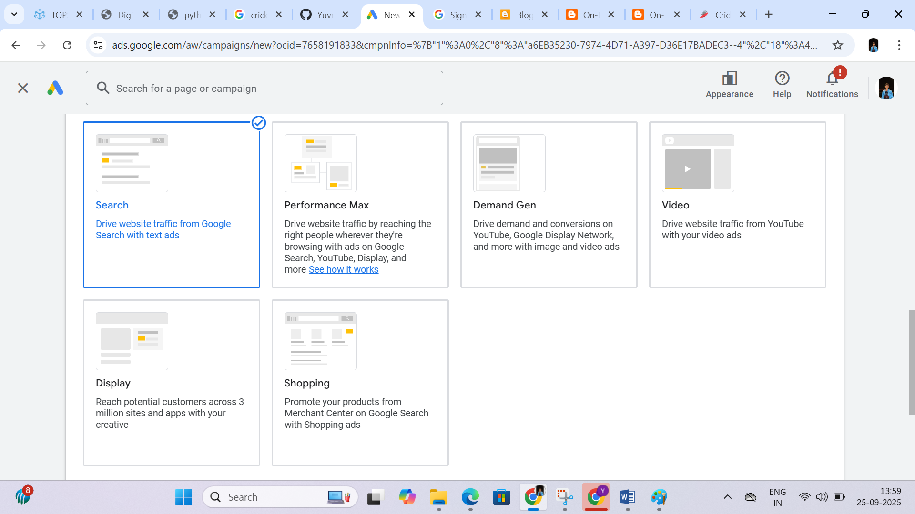

Step:3

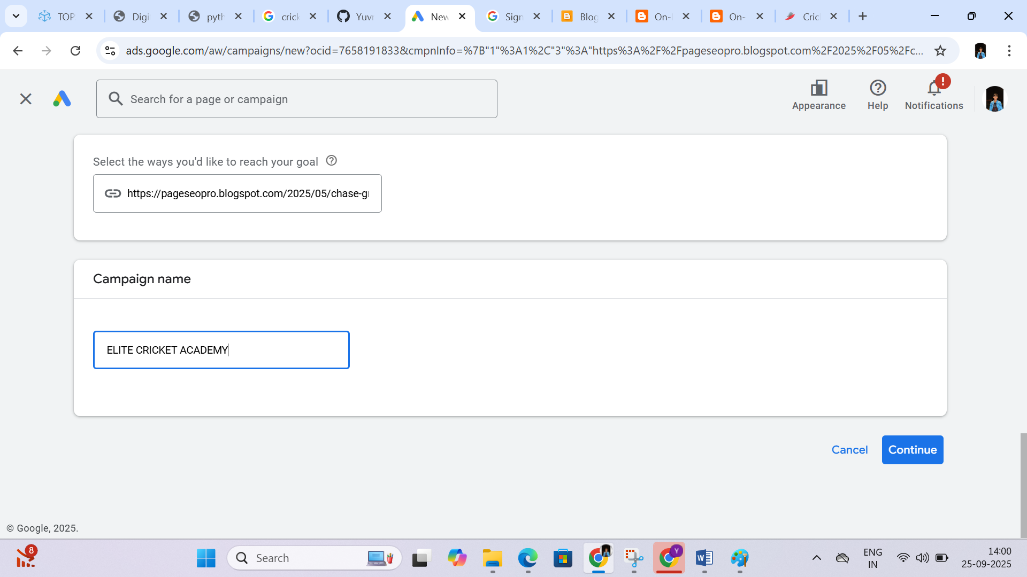

Step:4

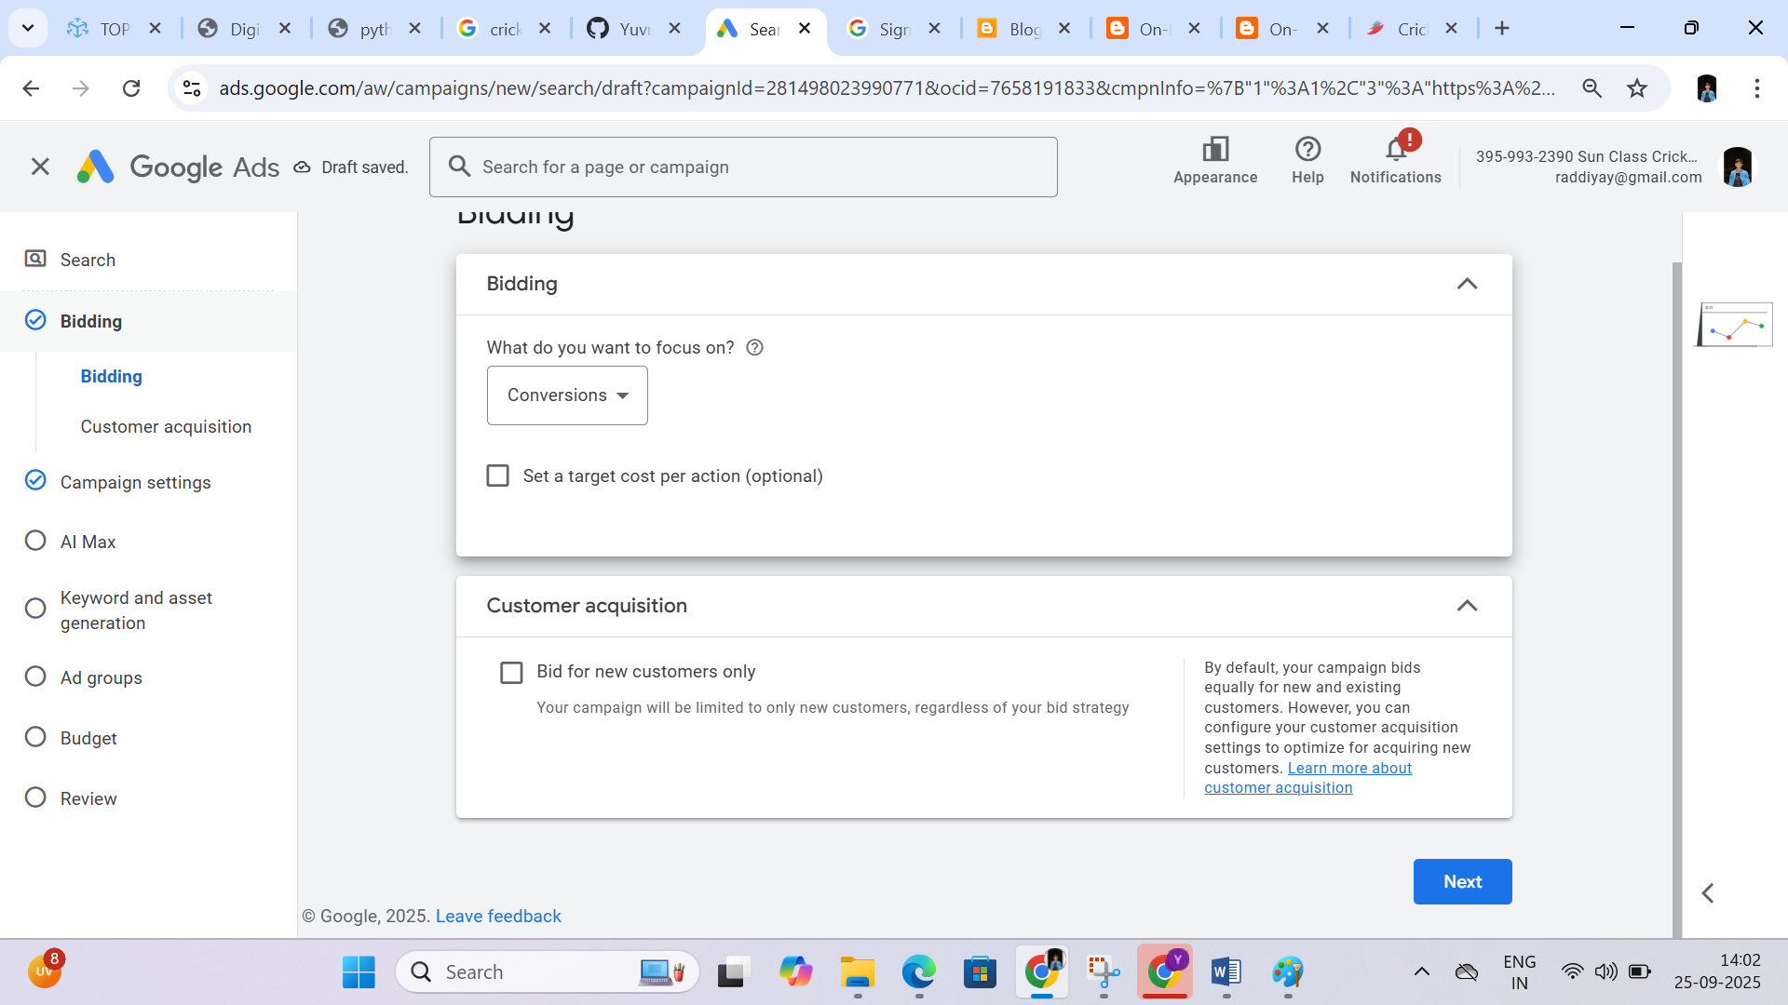

Step:5

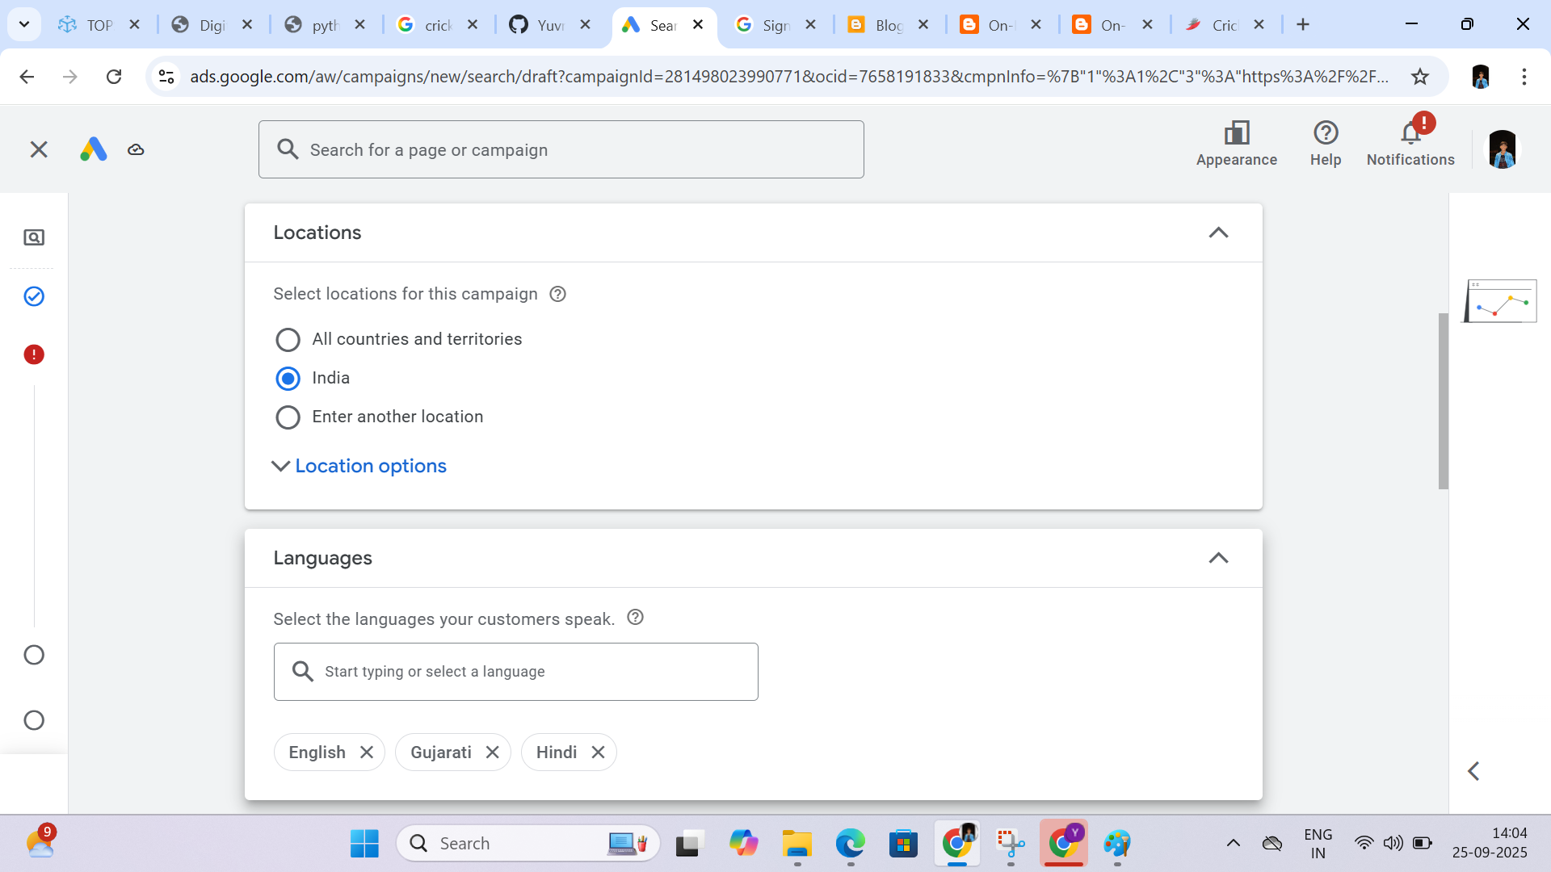

Step:6

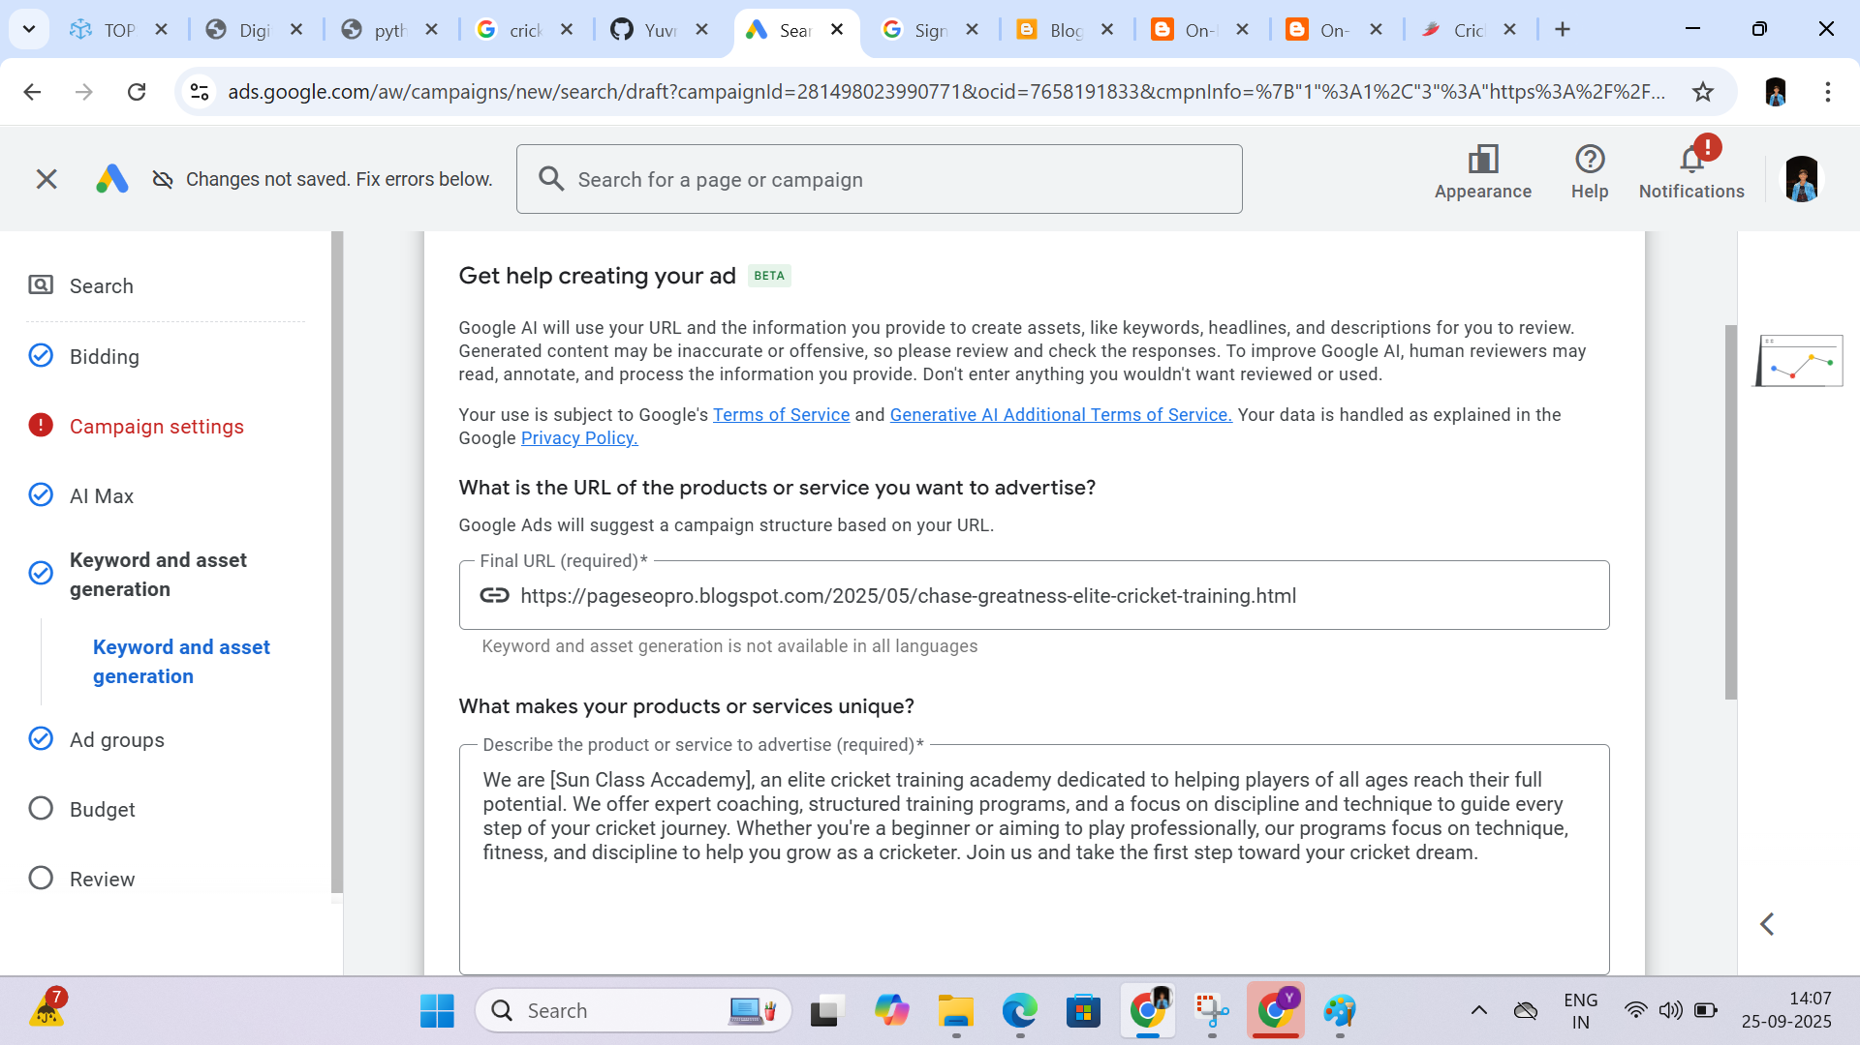

Step:7

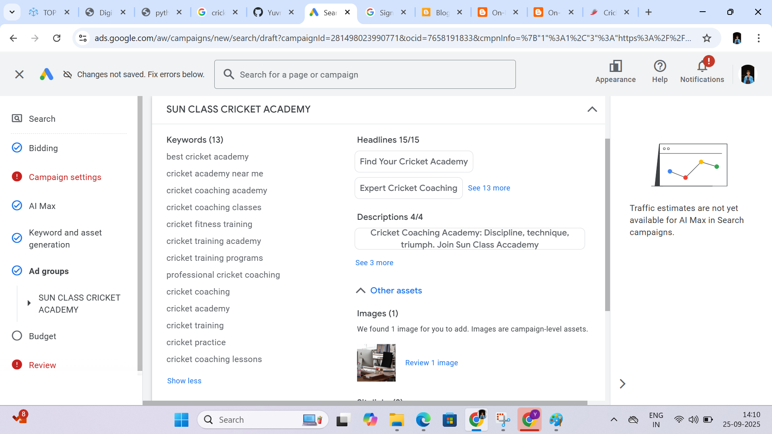

Step:8

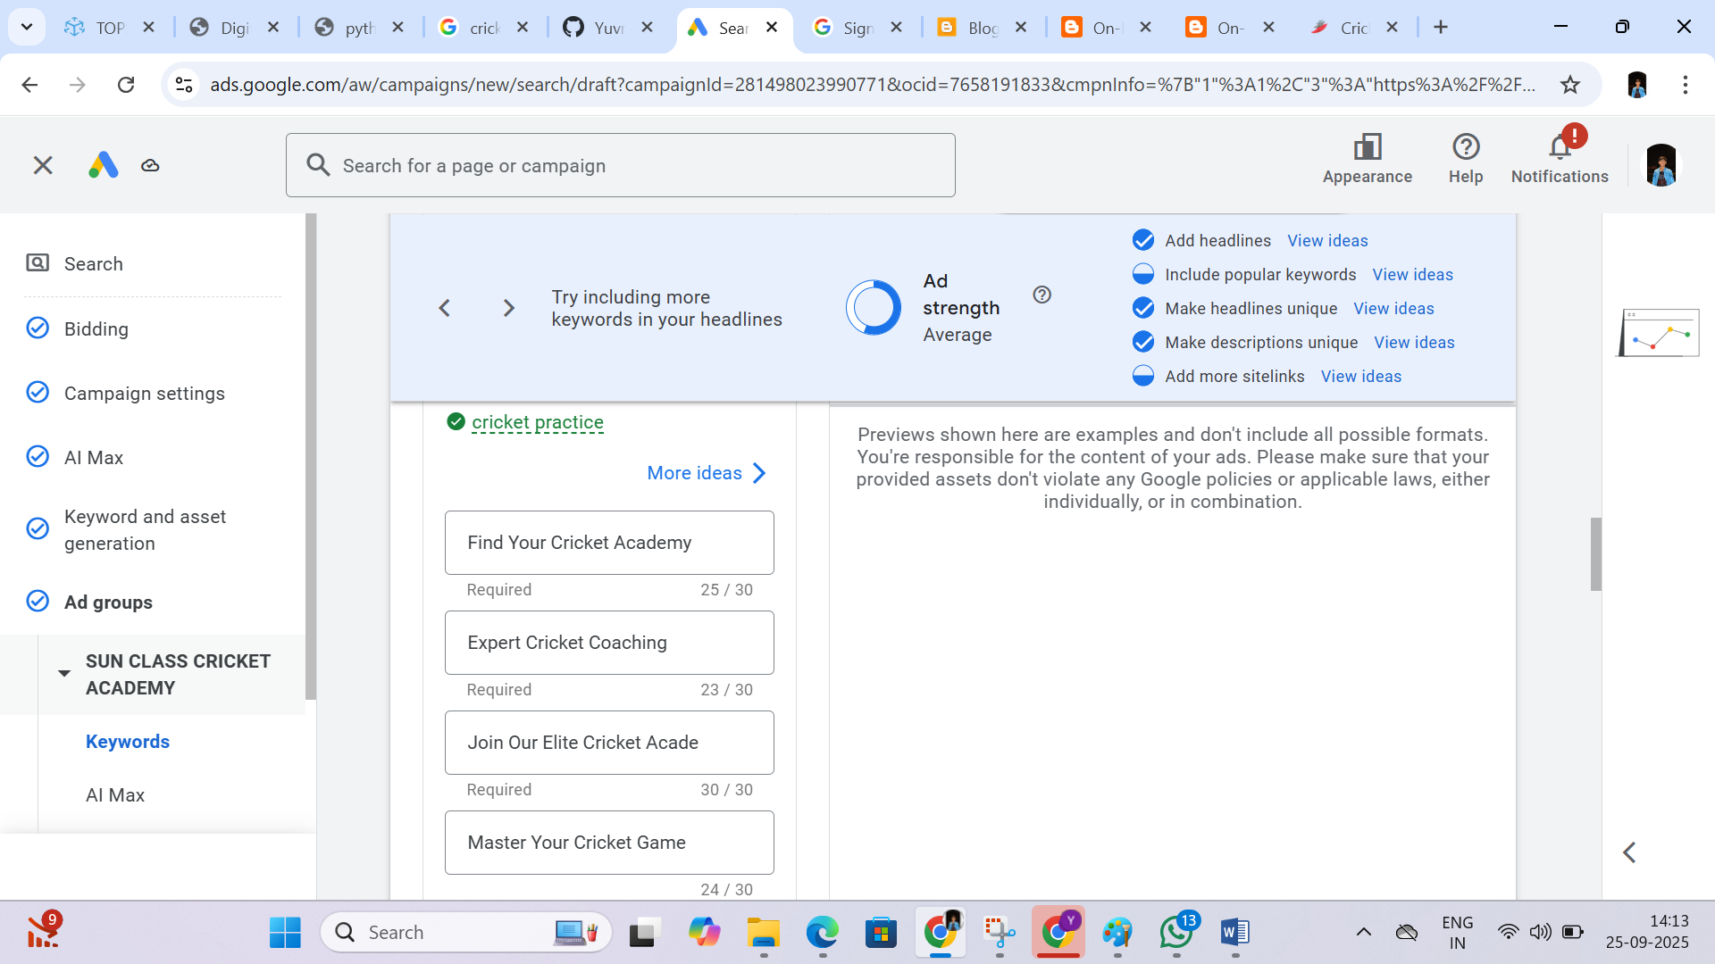

Step:9

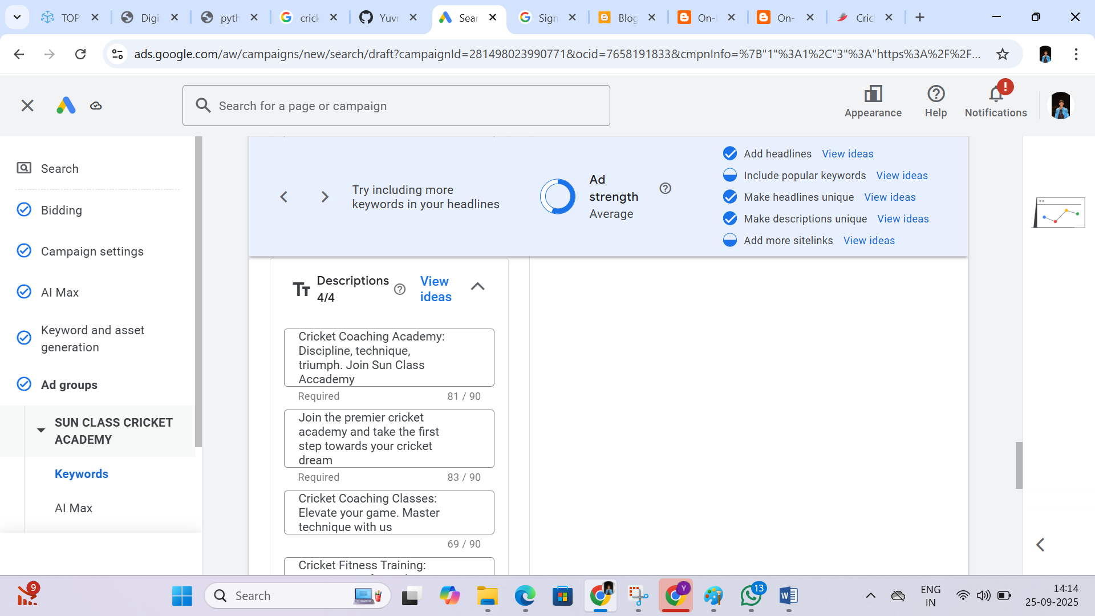

Step:10

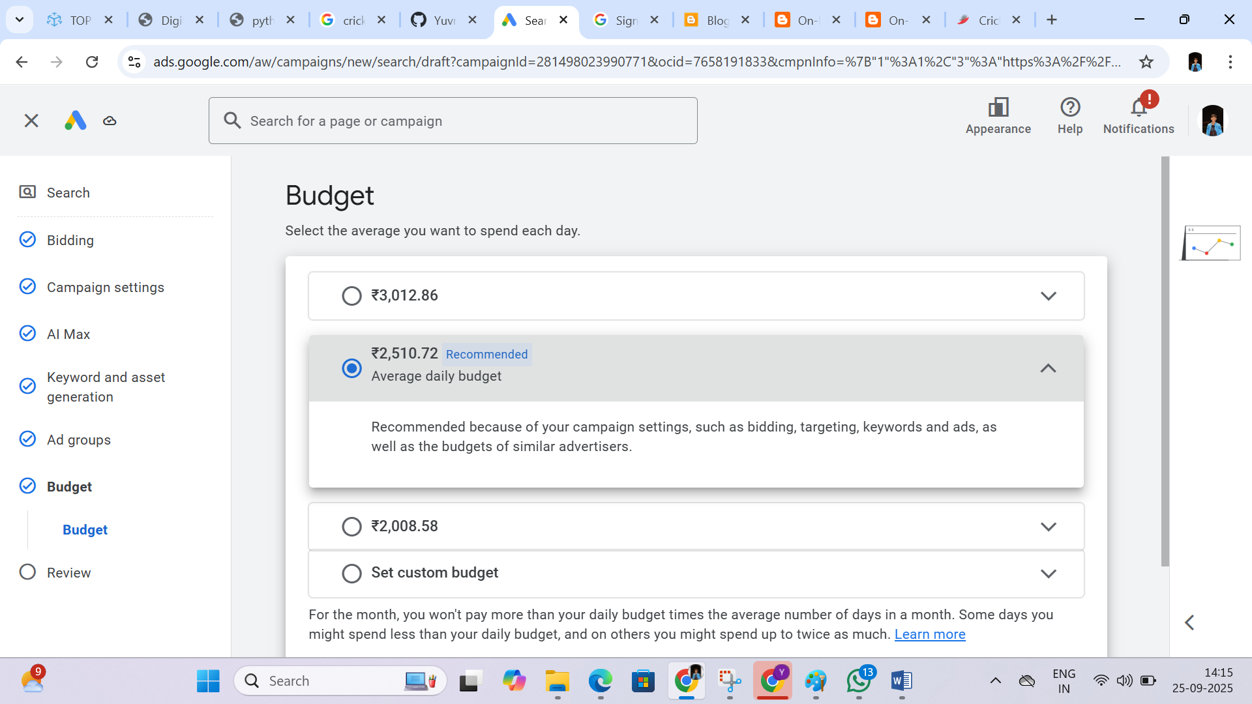

Step:11

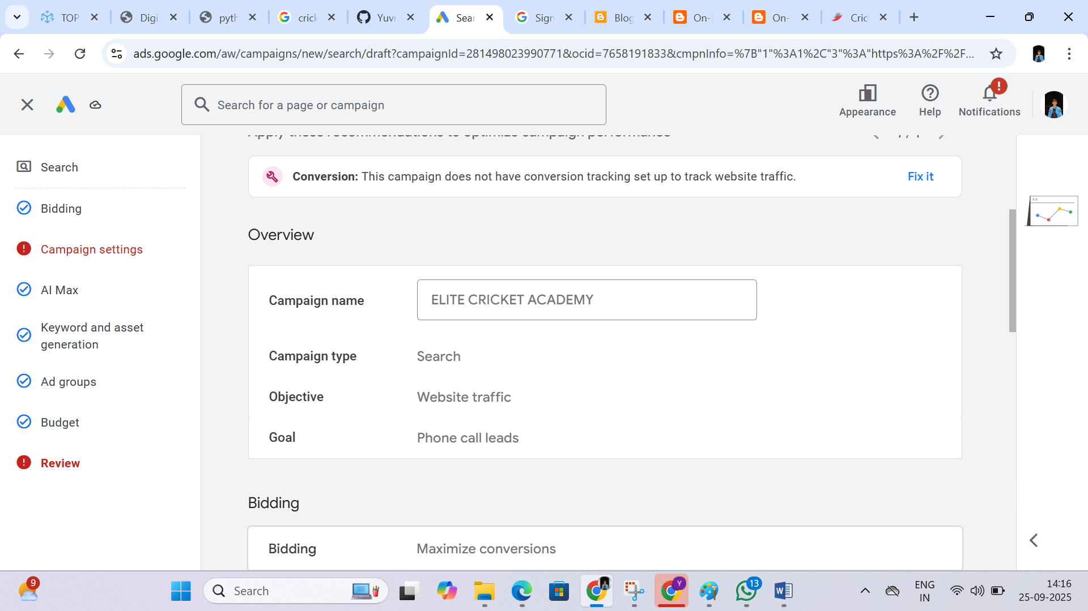

Step:12

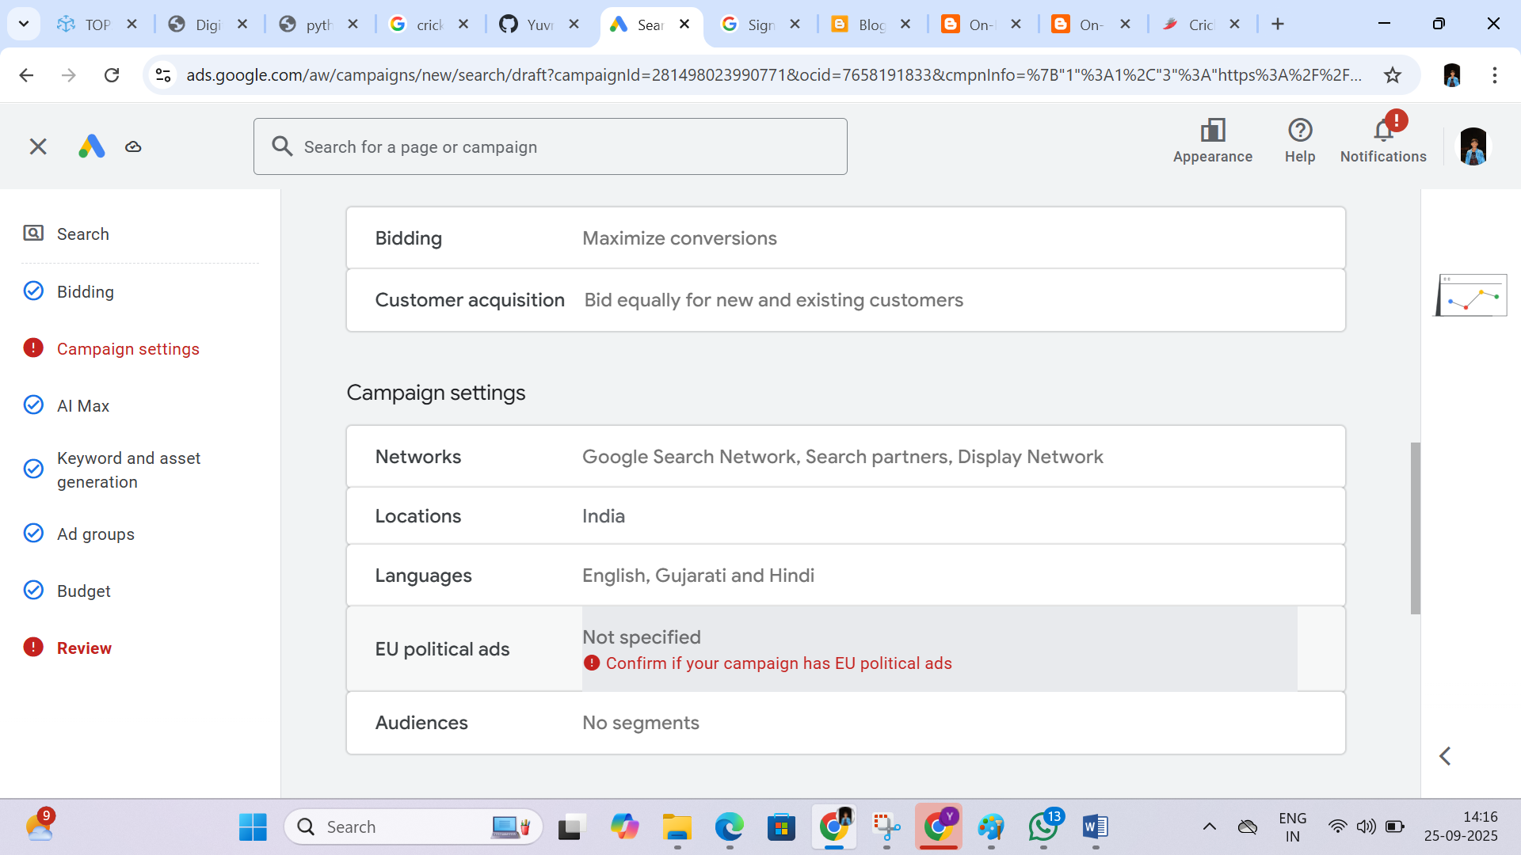

Step:13

